

Can Growth be Achieved Without Risk?

Peter Hendrickson | BUS 567 | December 12, 2018

# **Introduction**

Since its inception, the BlackRock Global Long / Short Equity Fund (“the Fund) has consistently outperformed its BoFA Merrill Lynch 3-month T-Bill Index benchmark in virtually all relevant financial measures without exposing the Fund to significant risk. This outperformance has been achieved using a complex automated position rebalancing system that incorporates the use of derivatives with both short and long positions. The outperformance while employing such a strategy brings up the consideration of whether it is possible to create a relatively risk-free Fund that outperforms a T-Bill type benchmark over the long-term. If this is possible, would it be fair to assume that in today’s automated world, that growth could be achieved without risk? Would this cause Swensen to rethink his allocation in risk-free Treasury Bonds and the importance of the culture of the investment team in favor of automation? Or is this another attempt at risk elimination doomed for failure like the former Long-Term Capital Management, who once advocated that high returns were possible without risk? Have we progressed through automation to directly confront risk through the systematic employment of complex derivatives once and for all? Is the Fund simply setting up another fall from grace as market conditions worsen? Or will outperformance only increase with a short bias? We will explore these concepts while examining the operations of the Fund as the progressive waive of the future for investment management as automation continues to increase.

Currently, the Fund maintains the $615 million assets under management with a net short bias consisting of 571 long and 606 short holdings. The Fund started in 2012 and has achieved a 26.28% total return since inception in comparison to a total return of 2.67% for the benchmark. The Fund’s best three months returned 4.6% and worst three months returned -5.89% since inception with a standard deviation of approximately 1% per month. It maintains a Morningstar Bronze rating given to only the top 10% of its class. The Fund, which is open to all investors, has a relatively high net expense ratio of 1.64%. However, when considering the complexity of dynamically hedging positioning for nearly 1200 combined short and long holdings, it is not surprising that higher fees apply. It is uncommon for a Fund that is open to the public to be hedged to such a degree that most positions are merely biased in either a short or long position, but rarely uncovered without a near equal opposing position. This ratio and the high number of positions reflects a level of sophistication only possibly achieved through automation. Is it time for Swensen to concede that the computer and the dynamics of derivatives have permanently changed the game? Or is this just a passing phase that will not achieve longstanding results? How can we assess the adherence to the investment philosophy when the management is essentially automated? Is it possible for a human to be more disciplined than a computer? Will great investment professionals like Swensen and others like world chess champions, be outperformed by automation?

**Summarized Investment Philosophy**

The following represents a summarized version of a much larger and more complex investment philosophy:

* Global Long/Short Equity Fund invests at least 80% of its total assets in equity instruments and related derivative instruments in developed markets. The Fund may invest in securities of issuers of any market capitalization and in securities denominated in either U.S. or foreign currencies. The Fund pursues its investment objective in both long and short positions in developed market equity instruments. The Fund maintains long and short positions primarily using swap agreements and other derivative instruments, such as futures. The use of both long and short positions better enables the Fund to produce returns that have low correlation to the market.
* The Fund looks to identify overvalued, undervalued or mispriced stocks and other equity instruments through proprietary techniques. Under normal circumstances, the Fund anticipates it will allocate approximately 40% of its assets in securities of (i) foreign government issuers, (ii) issuers organized or located outside the US, (iii) issuers whose securities primarily trade in a market located outside the US, or (iv) issuers doing a substantial amount of business outside the US, which the Fund considers to be companies that derive 50% of its revenue or profits from business outside the United States or have 50% of its sales or assets outside the United States.
* The Fund will allocate its assets among various regions and countries. Equity instruments consist of: common stock, depositary Receipts, derivative securities, or instruments such as futures, options, contracts for difference, forward contracts and swaps.

**Asset Allocation**

Target asset allocations are not officially released for public dissemination; however, the following allocations are based on current positions according to most recent informational disclosures through Bloomberg and the BlackRock’s website.

|  |  |  |  |
| --- | --- | --- | --- |
| **SECTOR BREAKDOWN (%)** | **Long** | **Short** | **Net** |
| **Industrials** | **22.9** | **-23.8** | **-0.9** |
| **Consumer Discretionary** | **25.5** | **-19.5** | **6** |
| **Information Technology** | **20.5** | **-14.4** | **6.1** |
| **Materials** | **14.5** | **-13.4** | **1.1** |
| **Health Care** | **8.4** | **-12.7** | **-4.3** |
| **Consumer Staples** | **9.9** | **-9.7** | **0.2** |
| **Real Estate** | **8.9** | **-7.6** | **1.3** |
| **Utilities** | **4.9** | **-7.2** | **-2.3** |
| **Communication** | **3.9** | **-6.1** | **-2.2** |
| **Energy** | **3.5** | **-4.3** | **-0.8** |
| **Cash or Other Derivatives** | **0** | **-2.1** | **-2.1** |

|  |  |  |  |
| --- | --- | --- | --- |
| **TOP COUNTRIES (%)** | **Long** | **Short** | **Net** |
| **United States** | **73.7** | **-82.5** | **-8.8** |
| **Cash or Other Derivatives** | **16.8** | **-17.2** | **-0.4** |
| **United Kingdom** | **10** | **-11** | **-1** |
| **Japan** | **11.4** | **-8.2** | **3.2** |
| **Germany** | **14.4** | **-4.7** | **9.7** |
| **France** | **6.8** | **-10.6** | **-3.8** |
| **Netherlands** | **9.6** | **-1.7** | **7.9** |
| **Australia** | **4.4** | **-3.9** | **0.5** |
| **Canada** | **2.9** | **-1.9** | **1** |
| **Sweden** | **1.8** | **-3** | **-1.2** |

Assessing the overall asset allocation strategy most recently employed, the Fund is heavily diversified in nearly all sectors of the domestic economy while maintaining a significant global presence. The allocation strategy is in favor of assuming both long and short positions with a net bias towards BlackRock’s global forecast. The sophistication of maintaining such global positioning cannot be achieved without a high degree of automation and systematic financial modeling. The level of detail required is well beyond the qualifications of the four-man management team currently employed to carry out the Fund’s objectives. For this reason, the Fund utilizes a combination of backside support from its parent firm, BlackRock, with a sizeable automated aspect to manage its operation.

**Asset Class Management**

The Fund is consistent in its application of its prescribed investment philosophy for identifying overvalued, undervalued, or mispriced stocks and other equity instruments through its proprietary automated techniques. The Fund takes long positions in securities that BlackRock has identified as attractive in both growth prospects and valuation and short positions in such securities that BlackRock has identified as overvalued or poised for underperformance. This compliance makes a strong case that most of the Fund is operated with a highly-sophisticated decision modeling emphasis. Is this the managerial model that Swensen will be moving towards with his management of Yale’s Endowment Fund in the years to come? Or is this a passing phase that has no sustainability? How much can management really take credit for results when this high of a degree of automation exists? It would be hard to argue that such a level of depth and coordination could be maintained while being active in the derivative markets without the use of systematic automation. This may be why the Fund maintains such a disciplined approach. Perhaps it is not humanly managed to a large degree and thus adheres more closely to its investment philosophy than even Swensen’s team could maintain.

**Short characteristics: 19.82 PE, 2.13 PB $25,936M Market Cap**

**Long characteristics: 17.46 PE, 2.18 PB $20,571M Market Cap**



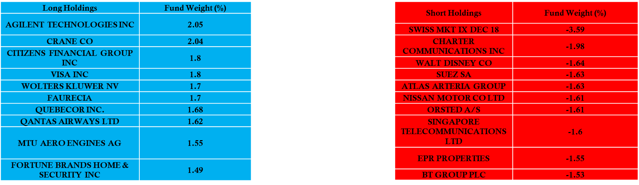

**Risk / Return**

* Risk is systematically hedged with opposing positions referencing long / short
* Due to correlations of up to 75% in the movement of stocks with the overall market, the positions of 571 Long verses 606 Short significantly mitigate both returns and losses
* Although the Fund is not without risk, it is heavily hedged against major losses

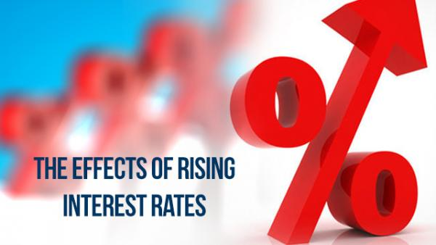

* Standard deviations are generally less than 1% per month
* Alpha is generated primarily with short positions
* Current market situation favors out-performance over the benchmark for the fund if trends continue

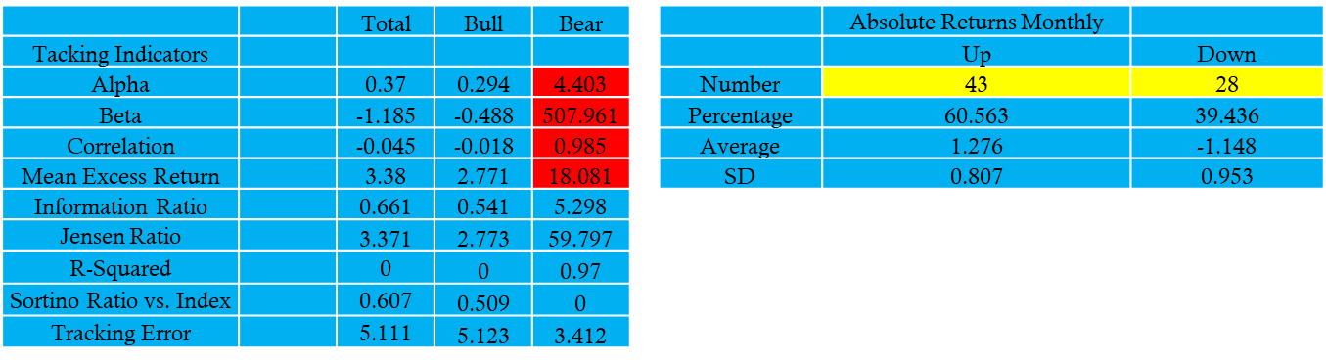

**Fund Management Style**

The management style follows a systematic valuation and overvaluation assessment to determine long and short positions. Assessing the Funds’ positions, they follow an automated risk mitigation approach to assuming its short and long positions to ensure that proper risk mitigation is maintained. Assessing the fund’s historical SD, makes a strong case for effective automated risk management. The Fund’s current holdings of nearly equal short and long positions and its relative net weights per industry and region are not significantly different to expose the Fund’s assets to substantial losses. There have been no serious changes in discipline in terms of the application of the Fund’s Investment Philosophy that would be a cause for concern.

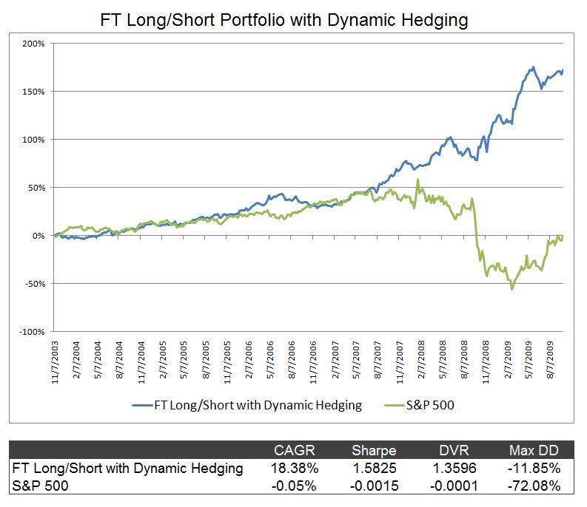

**Trends in Strategy**

The Fund’s strategy has not been significantly altered in recent years. Assessing the overall strategy, it appears that there is a slight increase in short bias, which is consistent with the recent domestic and global market trends. The Fund consistently hedges its domestic positions with current global risk models. It generally follows a quantitative approach that consistently mitigates its risk through its assumption of offsetting short and long positions. It continues to take advantage of trends in valuation that arise during market fluctuations and is currently ensuring that it is hedged with a short bias that positions the Fund to outperform its benchmark. As the Fund grows, it is anticipated that no significant alterations to the operational strategy will be employed. In this regard, the Fund is employing a highly-disciplined approach consistent with its investment philosophy.

**The Argument for Complex Decision Modeling**

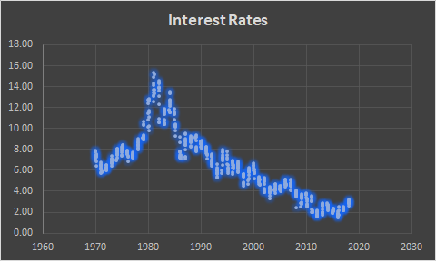 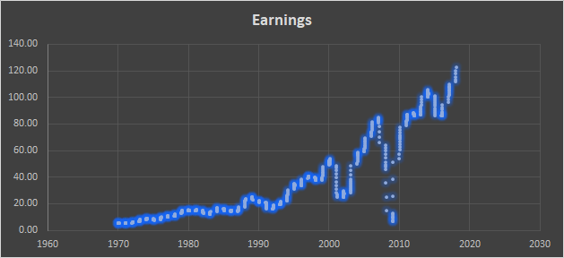

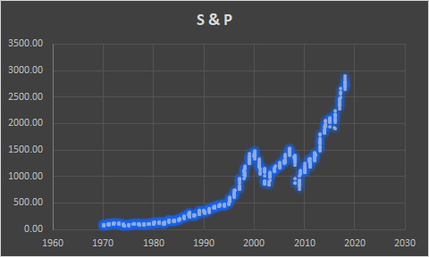 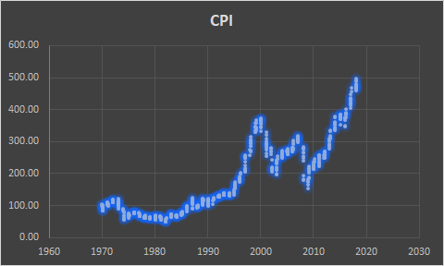

Past are days when investment decisions are based on internal assessments or unsystematic evaluation. The level of sophisication demonstrated by the Fund combined with the achievement of consistent returns provides substantial validation for the incorporation of complex decision modeling in the investment decision making process. Currently, major financial firms are seeking individuals, not with financial backgrounds, but with mathmatical and engineering educations who are capable of systematically implementing complex investment decision making models. Most common are models that demonstrate correlation between specific economic and market data. These models are beginning to form the basis for a significant portion of investment activity.

What advice would Swensen have for this trend? The speed of implmentation and the ability of large computing power to forecast results and to demonstrate how current market conditions can be correlated to patterns in the past, leaves those that do not implement such models at a disadvantage. The market continues to accelarate in speed and those that fail to automate appear to be left behind. What about Swensen’s illiquid, long-term approach? This may be why he continues to increase his exposure to private equity, venture capital, and other alternative asset classes. Perhaps he realizes that he does not have an advantage in competing with those that employ shorter term strategies highly integrated with automation and systematic risk reduction with derivatives.

BlackRock conversely continues to embrace and employ technology nearly better to anyone on the planet. They use their prediction models to forecast their positions and systematically cover their exposure with complex derivative strategies. In this manner, as proven by the performance of the Fund, they can outperform conversative benchmarks without significantly increasing risk. How can Swensen argue with this approach? The evidence supports that he realizes that he is behind the curve and like the great investor that he is, has decided to invest in where he continues to have an advantage, in long-term illiquid investments that require patience, dilligence, effective management, and iron-clad discipline. This is what has worked and continues to work for Yale’s Endownment Fund. In this sense, Swensen, because he has access to the very best niche managers, may be able to hold off on entering direct competition with organizations that employ sophisicated modeling. He also is likely to employ managers that implement these strategies rather than attempt to beat them at a game that he cannot likely win. It is this wisdom in knowing his limitations that continues to produce great returns for his organization despite his resistance to fully embrace automated investment management.

**The Way Forward**

The Fund will likely do well over the next few years if international central banks continue to implement contractionary monetary policy. Since the fund invests tends to generate most its alpha from short positions, it is likely that the Fund will outperform its benchmark to a significant degree. As a result, the expectation is that the Fund will continue to perform in the top 10% of its class relative to its previous performance in earning a Bronze rating by Morningstar. The way the Fund is hedged also sufficiently mitigates the potentially negative effects of a black swan geopolitical event on performance. It is also likely that such an event may increase returns due to short bias in terms of international valuation modeling.

 

**Conclusion**

 In this analysis, the Fund validated its strength and leadership relative to its industry. Achieving high returns with limited risk is not achieved by chance. It is the result of strong systematic financial management. BlackRock is a strong partner in the formulation of the new financial markets. It is implementing the most cutting edge technology in the world. It is presenting new solutions for the future of investing by integrating AI, Deeplearning, Datacenters, and blockchain technology. The analysis of the investment philosophy and the operational success of the Fund demonstrates that it is effectively implementing strategies that have generated superior results confirmed by its financial performance relative to risk. Due to its expertise in risk management employed through derivative strategies and their effective decision models, BlackRock is a projected leader for developing the future automated growth for Deeplearning, AI and its numerous applications within the investment industry.

From a pure financial perspective, the Fund has relative returns in earnings at a higher rate than their benchmark risk. This performance makes a strong case for the implementation of automation in the investment decision and operational process. The demonstrated complexity of the Fund is not easily duplicated with a more traditional management strategy. Due to their integration of complex systematic risk reduction through the use of derivatives, they are able to assume higher returns with lower relative risk than their peers. This is noteworthy and is likely to cause those like Swensen to either acknowledge that they cannot recreate this combination of low risk and high relative returns so why not join hire a similar Fund, due to the impossibility of implementing a similar strategy without a high level of automation. In this sense, the financial markets are welcoming a brave new world that moves faster with less risk than ever humanly imagined. The future is near and even Swensen will have to acknowledge that it may cause him to rethink his asset allocation to include managers that employ complex derivative strategies that can increase his returns significantly. If not, he runs the risk of being left behind and reducing his returns relative to the competition. This is not likely to occur given his strong historical performance; therefore, we can expect others like Swensen to embrace these new developments and to welcome in a new world where risk is reduced through complexity.